Introduce of NLTK and optimization of machine learning model

# This paper is a extend review of the research Using machine learning in chat box for heart disease prediction. In the research, two machine learning methods k-Nearest Neighbors (KNN) and Support Vector Classifier are used to build for heart disease prediction. Another tool used in the research is NLTK. So as a extend review of the research, the topic of this paper is optimize the parameters of SVM and introduce the tool NLTK for natural language processing.

SVM

The Support Vector Machine (SVM) algorithm (Cortes and Vapnik, 1995) is probably the most widely used kernel learning algorithm. It achieves relatively robust pattern recognition performance using well established concepts in optimization theory

Optimal hyperplanes are useless when the training set is not linearly separable. Kernels machines (section 2.2) can represent complicated decision boundaries that accomodate any training set. But this is not very wise when the problem is very noisy. Cortes and Vapnik (1995) show that noisy problems are best addressed by allowing some examples to violate the margin constraints in the primal problem (1). These potential violations are represented using positive slack variables ξ = (ξi . . . ξn). An additional parameter 4 Support Vector Machine Solvers C controls the compromise between large margins and small margin violations

What dose the kernel parameter of the Gaussian RBF kernel signify?

First of all, the function expression of Gaussian kernel is shown as below, the sigma is standard deviation. It determines the width for Gaussian distribution. 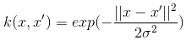

We can infer that, for a larger value of sigma, the decision boundary is more likely to be flexible and smooth. Which means it is more likely to make the wrong decision while predicting, but the merit is it can help avoids the potential risk of overfitting. For a smaller sigma, by contrast, the decision boundary is strict and sharp, so the demerit of this is, the hazard of overfitting.

What happens when a hard-margin SVM is fit to a dataset of two classes with overlapping features. What value do you need to set C (the slack-variable hyper-parameter) to attain a hard-margin SVM?

Regarding to the hard-margin SVM, in the very beginning, the We assumed training data are linearly separable in mapped space like the figure below. And We want to maximize this margin $\frac{M}{|\left|w\right||}$ without the loss of generality. If training samples are not linearly sparable, it has no solution. When the data is linearly separable, and we don’t want to have any misclassifications, we use SVM with a hard margin. However, when a linear boundary is not feasible, or we want to allow some misclassifications in the hope of achieving better generality, we can use soft margin SVM for classifier. In real world problem it is not likely to get an exactly separate line dividing the data within the space. And we might have a curved decision boundary. We might have a hyperplane which might exactly separate the data but this may not be desirable if the data has noise in it. It is better for the smooth boundary to ignore few data points than be curved or go in loops, around the outliers. This is handled in a different way; here we hear the term slack variables being introduced. Now we have, yi(w’x + b) ≥ 1 - Sk [4] [12]. This allows a point to be a small distance Sk on the wrong side of the hyper plane without violating the constraint. Now we might end up having huge slack variables which allow any line to separate the data, thus in such scenarios we have the Lagrangian variable introduced which penalizes the large slacks. min L = ½ w’w - ∑ λk ( yk (w’xk + b) + sk -1) + α ∑ sk Where reducing α allows more data to lie on the wrong side of hyper plane and would be treated as outliers which give smoother decision boundary [

As for what value of C need to set to attain a hard-margin SVM. The purpose of Slack variables is tolerance of the violation of some constraints. In another word, some certain data points can be in the margin. But those points which are in the margin should be as less as possible, and surly the distance of the margin to be as small as possible

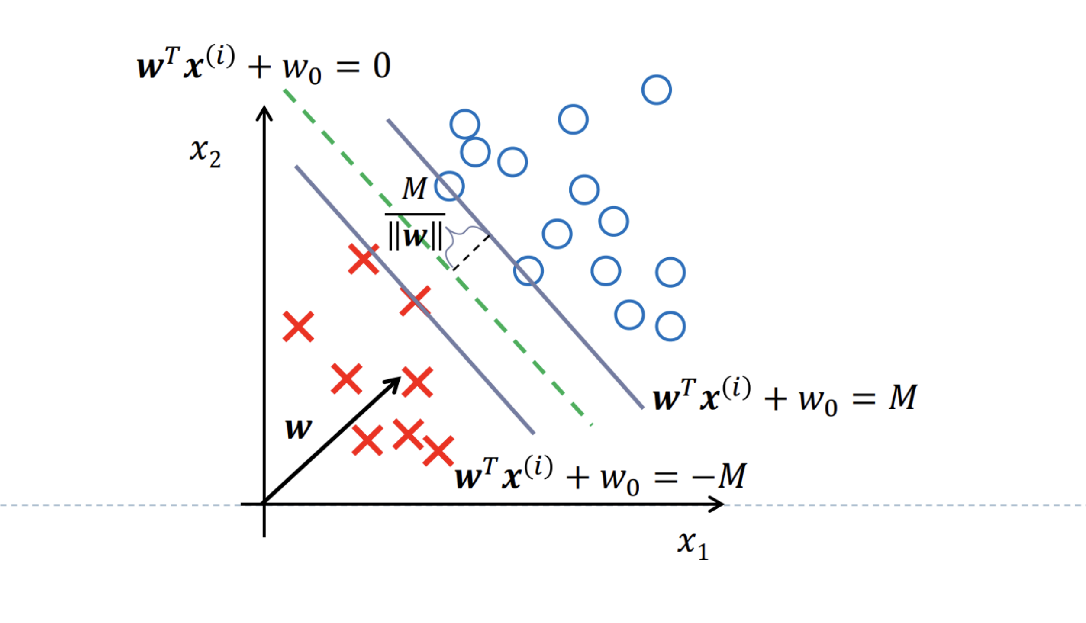

Why we need nested cross validation and what are the Inner nested cross validation and outer nested cross validation.

In machine learning we cannot apply all of data into training model, otherwise we will not have data sets to verify the model and evaluate the performance of the model. To solve this problem, the simplest and the most straightforward way is to divide the whole data set into two parts, one for training and another for verification, which is called training set and test set. However, this method has a serious drawback. The model’s performance and the selection of parameters highly depend on how the training set and test set is divided. So, if the division method of our training set and test set is not good enough, we may not be able to choose the best model and parameters. Nested cross-validation is to search the hyperparameters through the estimation of the generalization error of the model in order to get the best parameters of the model. The traditional validation methods as we mentioned above are only divides the data set into training set and test set, which cannot solve the problem of selecting the optimize model and choose the parameters of the model.

There are two kinds of loops in nested cross validation, which is called outer loop and inner loop. In general, the inner cross validation is taking charge of the hyperparameter tuning which means choose the parameters for the model. The outer loop is responsible for generalization error or in another word estimate the error. For example, random search or grid search. The outer loop provides training data for the inner loop while retaining part of the data for testing the inner loop model. In this way, the information leakage of the data can be prevented and a relatively low model score deviation can be obtained.

The basic opinion of cross-validation is to train a new model using a subset data of the whole data set, and then check the trained model on the rest of this date set. We are able to get the estimate of the generalization performance of the model by repeating the process several times and average the validation error.

Tokenization using NLTK

Solving an NLP problem is a multi-stage process. We need to clean the unstructured text data first before we can even think about getting to the modeling stage. Cleaning the data consists of a few key steps:1)Word tokenization 2)Predicting parts of speech for each token 3)Text lemmatization 4)Identifying and removing stop words, and much more.

Tokenization is one of the most common tasks when it comes to working with text data. Tokenization is essentially splitting a phrase, sentence, paragraph, or an entire text document into smaller units, such as individual words or terms. Each of these smaller units are called tokens. The tokens could be words, numbers or punctuation marks. In tokenization, smaller units are created by locating word boundaries. But what are word boundaries? These are the ending point of a word and the beginning of the next word. These tokens are considered as a first step for stemming and lemmatization. Before processing a natural language, we need to identify the *words* that constitute a string of characters. That’s why tokenization is the most basic step to proceed with NLP (text data). **This is important because the meaning of the text could easily be interpreted by analyzing the words present in the text.** There are numerous uses of doing this. We can use this tokenized form to count the number of words in the text and count the frequency of the word, that is, the number of times a particular word is present and so on.

NLTK, short for Natural Language ToolKit, is a library written in Python for symbolic and statistical Natural Language Processing.

NLTK contains a module called *tokenize()* which further classifies into two sub-categories:

**1.Word tokenize:**  This is use the word_tokenize() method to split a sentence into tokens or words

1. Sentence tokenize:  This is use the sent_tokenize() method to split a document or paragraph into sentences

Another way to deal with tokenization in NLTK is using the spaCy libracy. spaCy is an **open-source library** for advanced NLP It supports over 49+ languages and provides state-of-the-art computation speed.

**Keras is another useful framework for tokenization.** Keras! One of the hottest deep learning frameworks in the industry right now. It is an open-source neural network library for Python. Keras is super easy to use and can also run on top of TensorFlow.

In the NLP context, we can use Keras for cleaning the unstructured text data that we typically collect. The final tokenization method we will cover here is using the Gensim library. **It is an open-source library for unsupervised topic modeling and natural language processing** and is designed to automatically extract semantic topics from a given document.

Sentiment analysis

WordNet is lexical database for English language. It contains definitions of words according to their part of speech. Additionally, it provides synset(cluster) , synonyms of words and phrases. There are many research labs which provides their own version of WordNet. SentiWordNet is one of such type of WordNet which provides positivity, negativity and objectivity scores of the word in addition to the definition of the word. These scores are quite useful while classifying tweets as these scores are set after deep observation and analysis of semantics of that word in the real world. Each word can be classified according to its part of speech in English language. That's why, its positivity, negativity and objectivity score can differ for the different parts of speech. Sentiment analysis of large datasets has always been a hot shot. Although many methods are there for analysis but all are somewhat lacking when it comes to accuracy . To improve the accuracy one way is to train your system in a way such that it gets the sentiment of word based on the entire tweet i.e if a word in the tweet has more than one meaning then it compares all the meanings of the word and takes the one which best suits the sentiment of entire tweet . This approach needs development of advanced highly intelligent algorithms . But this approach is surely going to add to the present accuracy of sentiment analysis systems. The above explained sentiment analysis model has a flaw that it takes a lot of time in fetching data from twitter and in data management. This flaw can be overcome by use of Hadoop ecosystem instead of python as Hadoop ecosystem provides high speed processing of large data .

The ultimate goal of this blog is to predict the sentiment of a given text using python where we use NLTK aka Natural Language Processing Toolkit, a package in python made especially for text-based analysis. So with a few lines of code, we can easily predict whether a sentence or a review(used in the blog) is a positive or a negative review.

### Conclusion

This paper is a extend review of the research Using machine learning in chat box for heart disease prediction. This paper introduces some of the techniques used to conduct PRE experiments, especially for natural language processing and machine learning model SVM and its optimization. Optimize hyper parameter in Machine learning is really important in Machine learning. Because build a machine learning model can be described as approximating a function that maps examples of inputs to examples of outputs. Approximating a function can be solved by framing the problem as function optimization. This is where a machine learning algorithm defines a parameterized mapping function and an optimization algorithm is used to fund the values of the parameters that minimize the error of the function when used to map inputs to outputs.This means that each time we fit a machine learning algorithm on a training dataset, we are solving an optimization problem.